# ACHIEVEMENTS & performance

What did you do from 8th Nov 2018 to 30th November 2019? Any photos of the laptop project? Who do you want to thank? Any struggles moving the charity forward? Explain your fundraising was in goods hence the reason there isn’t much income and no expenditure/

From the outset of Stirling Aid , enjoyed partnership working with Charities in the field.

Stirling Aid Trustee’s worked with Edinburgh Direct Aid (EDA) to supply a school it’s IT in Lebanon. The school was mostly for displaced Syrian refugees and this allowed some kind of normal education, this was ongoing for the entire year where old laptops were taken in cleaned, repaired and sent. A total of 35 Laptops were sent to EDA . These were used in a local school set up in Lebanon in the town of Arsal. Fund raising was done purely in terms of donated goods hence no money was used . Any supplies of hardware that was needed was donated by Computer Division Ltd. , Stirling. For which the charity is grateful. These included hard drives, memory and valued time for repair engineers. Trustees themselves were active in repairs and encouraged donators to clean the machines. Local volunteers goods were collected and also dropped to EDA’s HQ to distribute clothes and stationary for the school.

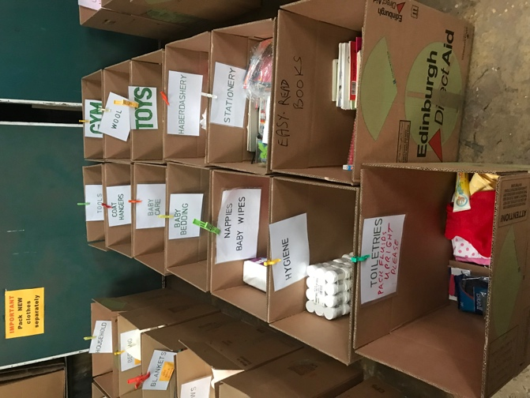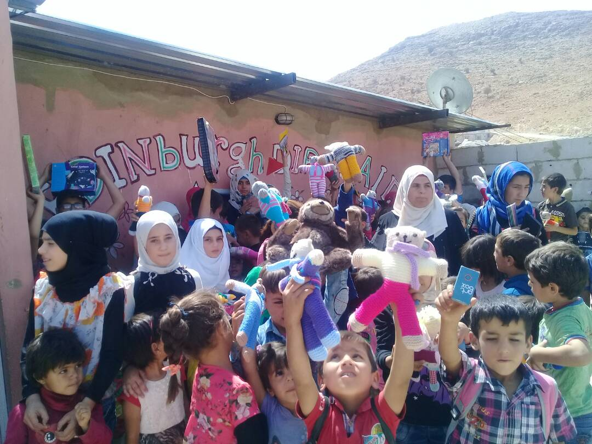

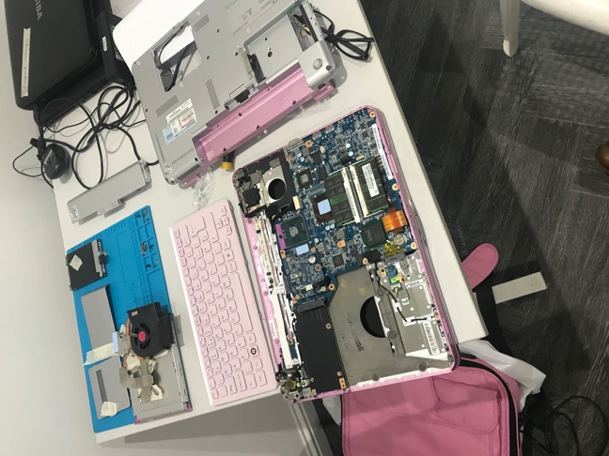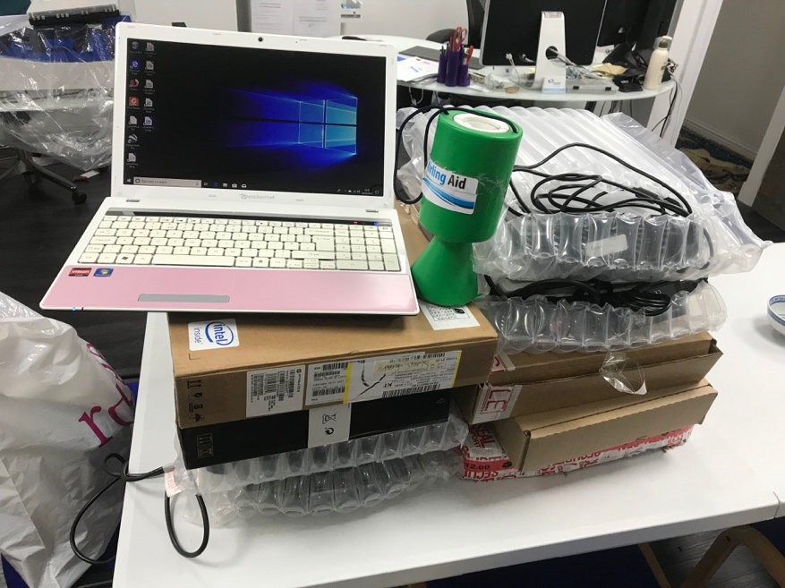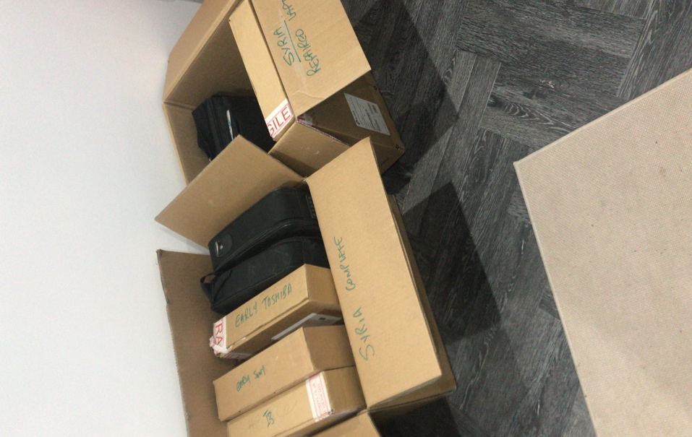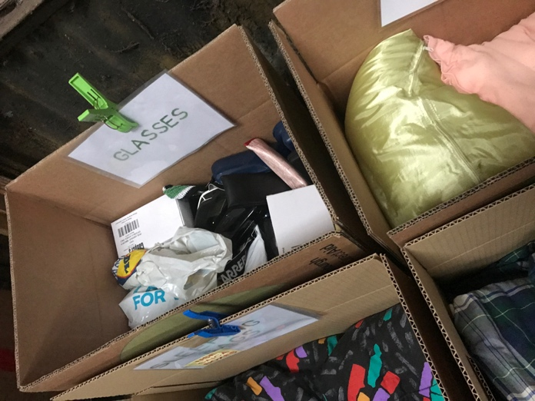

Thank you Edinburgh Direct Aid

Many Thanks to Anne Young, Stirling. EDA Chair Dennis Rutovitz, Jeanne Bell and David Mellay

The second main project was to support training for Fire/Ambulance/Lifesaving in Hebron working with the Fire Brigade Union in Dundee and helped by providing support whilst fire fighters arrived from Hebron in Palestine. The fire fighters were given training and instruction on continue to save lives. Trustees volunteer to help to support the event and raise awareness for their continued life saving work.

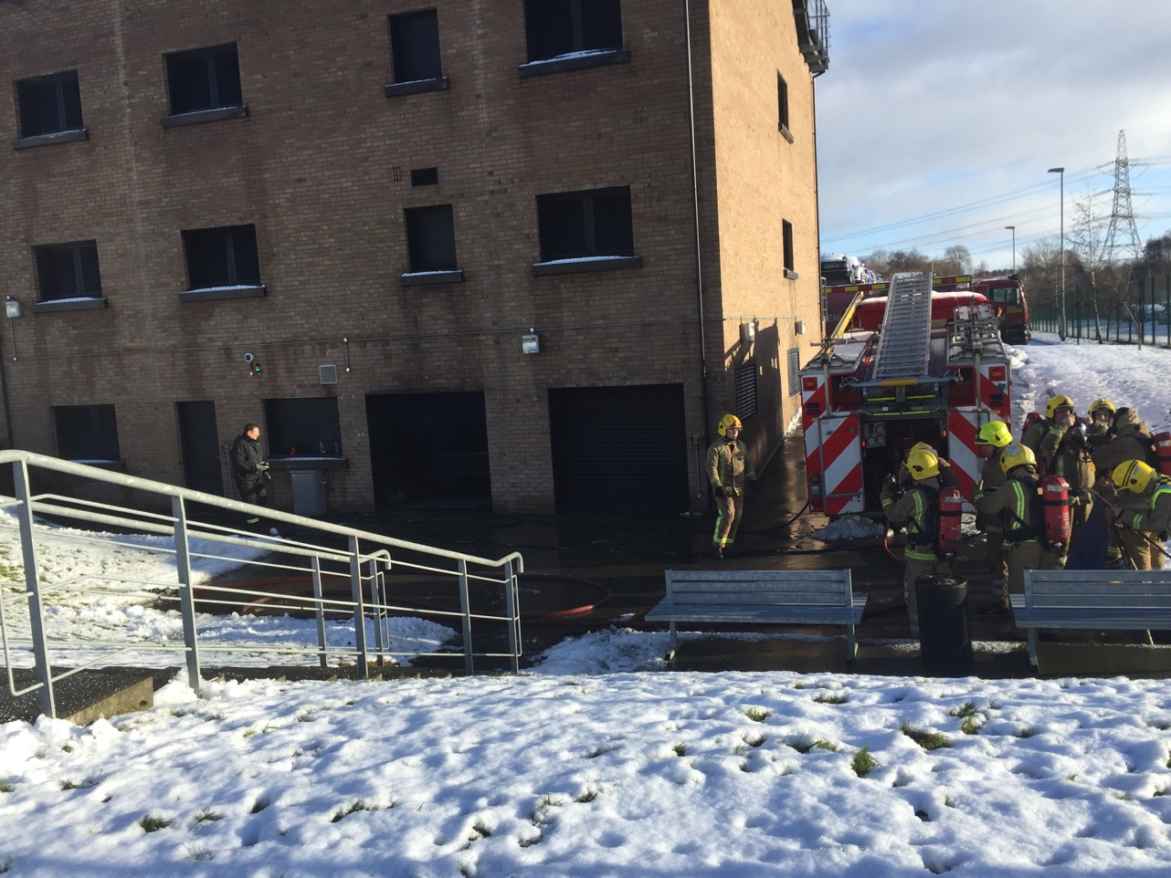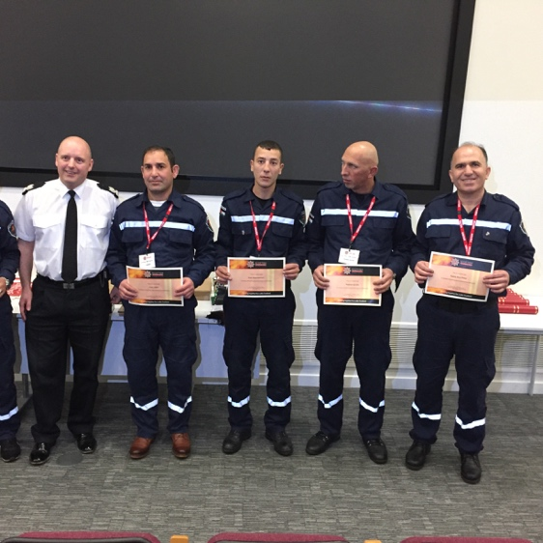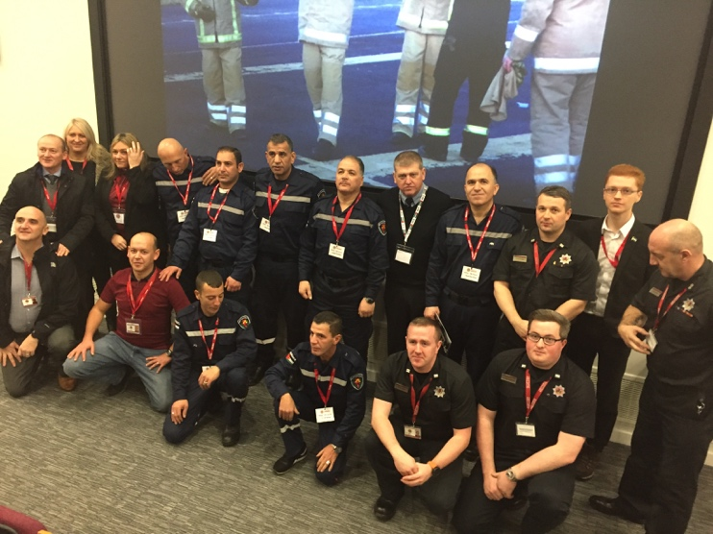

Many Thanks to Jim Malone – Fire Brigade Union

Working with Global Relief Trust

The Azra Bhatti, trustee spear headed a project together with , group at CRIC (Central Region Islamic Centre) were supporting an initiative to bring fresh water to those in need in Rohingya. The group help raise funds directly for Global Relief Trust as they had local feet on the ground. Stirling Aid will continue to strengthen its ties .

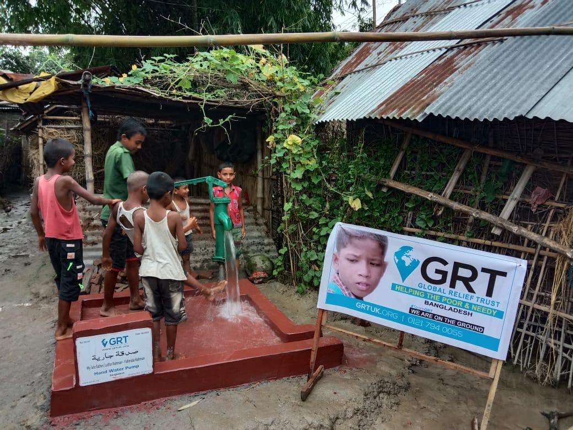

Many thanks to Shaheed Rahman GRT . The ladies at the Islamic Centre Stirling for assisting their time money and efforts for such a great cause

Future Projects

Due to Covid Restrictions all work will concentrate in helping Local organisations in 30mile Radius of Stirling.Scotland .

The Central Belt up to and including Perthshire including Glasgow with PPE and directly helping people who need food. Once again we will look to partner with organisations who need support.

We are looking to join Fareshare and help distribute foods.

